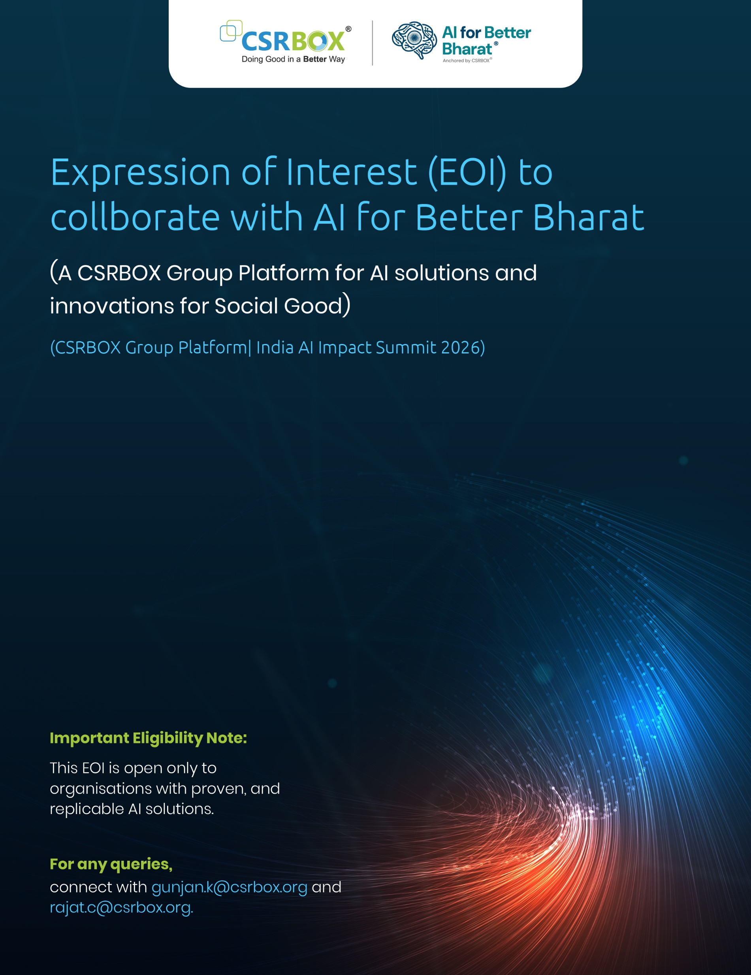

Section A: Organisation Details

1. Name of the Organisation (As per registration documents)

2. Type of Organisation
(Select one/checkbox)
- Corporate / Private Limited Company
- Technology Company / AI Solution Provider
- Startup (with live deployments)
- Social Impact Organisation
- Academic or Research Institution (with implemented AI deployments)
- Public / Quasi-Public Institution
- Other (please specify)

3. Primary Contact Name, Designation, Contact number and Email ID
(All communication related to shortlisting and next steps will be sent to this email)

4. Secondary Contact Name, Designation, Contact number and Email ID

Section B: AI Solution Overview

5. Title of the AI Project / Solution
(Please specify the name of the implemented solution being submitted)

5. Focus Area
(Select one/Checkbox)
- Healthcare
- Education & Skills (Future Tech Solutions)
- Sustainability
- Others (please specify)

Section C: Geographic Coverage

6. Current Geographic Coverage of the Solution
(Select all that apply)
- National
- Multi-State
- State-Level
- District-Level
- Community / Village-Level
- Other (please specify)

7. Specific Geography Covered
Please specify the State(s), District(s), City(ies), or Village(s) where the solution is currently implemented:

Section D: Stage of Implementation

8. Current Stage of the AI Solution
(Select one)
- Implemented (single-location or limited geography)
- Scaled Implementation (multi-location / multi-state / large user base)
- Mature / Institutionalised Implementation
Only implemented solutions are eligible. Prototype, pilot-only, or conceptual solutions will not be considered.

Section E: AI Use Case & Solution Description

9. Description of the Implemented AI Use Case
(Maximum 300 words)
Please describe:
- The problem addressed and its real-world relevance
- How AI is used in practice (not proposed use)
- Key AI technologies or techniques deployed
- Evidence of beneficiaries, adoption by users, institutions, or communities
- Key features ensuring responsible, safe, and explainable AI use

Section F: Impact, Outcomes & Beneficiaries

10. Proven Outcomes and Beneficiaries
Please clearly mention:
- Target beneficiary groups and number of beneficiaries reached to date
- Geographic regions where impact has been demonstrated
- Measurable outcomes achieved (quantitative or qualitative)
- Alignment with government systems, public programmes, or institutional frameworks, if applicable
Applications without demonstrated outcomes may not be shortlisted.

Section G: Replicability & Scalability

11. Replicability and Scale Potential in India (Maximum 250 words)
Please outline:
- How the solution can be replicated across districts, states, or sectors
- Evidence that the model is context-adaptable and sustainable
- Current or planned scale (District | State | National | Global South)
- Relevance to India’s AI ecosystem, Digital Public Infrastructure (DPI), or public systems
- Why this solution is relevant for AI for Better Bharat and India AI Impact Summit discussions

Section H: Supporting Documentation

12. Upload Project / Implementation Deck
(Mandatory | PDF or DOC format)
The deck should include:
- Problem statement and solution overview
- Implementation model and deployment details
- Impact data and outcomes
- Partnerships (if any) and governance approach
(Upload directly or provide a working link with access enabled to gunjan.k@csrbox.org and rajat.c@csrbox.org)

13. Upload Visual Documentation
(Optional)
Please upload up to 4 high-resolution visuals, such as:
- Field implementation photographs
- Screenshots of the AI system or dashboards
- Beneficiary interaction or deployment evidence
(Provide a working link)

Section I: Cost & Sustainability (Indicative)
15. Indicative Cost of Deployment (for CSR / Public Contexts)
(Select one – non-commercial, approximate)
☐ < ₹10 lakh per year
☐ ₹10–25 lakh per year
☐ ₹25–50 lakh per year
☐ ₹50 lakh–₹1 crore per year
☐ > ₹1 crore per year
☐ Depends on scale/geography (please explain briefly)
16. Funding & Sustainability Model
How is this solution currently funded? (Select all that apply)
☐ CSR
☐ Government
☐ Philanthropic / Grants
☐ Client-paid
☐ Hybrid
☐ Other

Section J: Declaration & Consent

14. Declaration of Authenticity and Consent
I hereby confirm that:
- The AI solution submitted is implemented, proven, and currently operational
- The information provided is accurate and verifiable
- I consent to CSRBOX reviewing and using this submission solely for evaluation, curation, and knowledge purposes related to AI for Better Bharat and India AI Impact Summit 2026
☐ Yes
☐ No

Terms and Conditions:
- Interested organisations must submit this filled form (in pdf format) and share to the below email address:
Mail: gunjan.k@csrbox.org and CC: rajat.c@csrbox.org
- Applications are reviewed on a rolling basis due to limited curation capacity. Only shortlisted organisations will be contacted for subsequent stages.
- Shortlisted applicants may be requested to further supporting documents such as dashboards, reports, or visuals etc
- Please note that Submission of an EOI does not guarantee selection or showcase participation.

