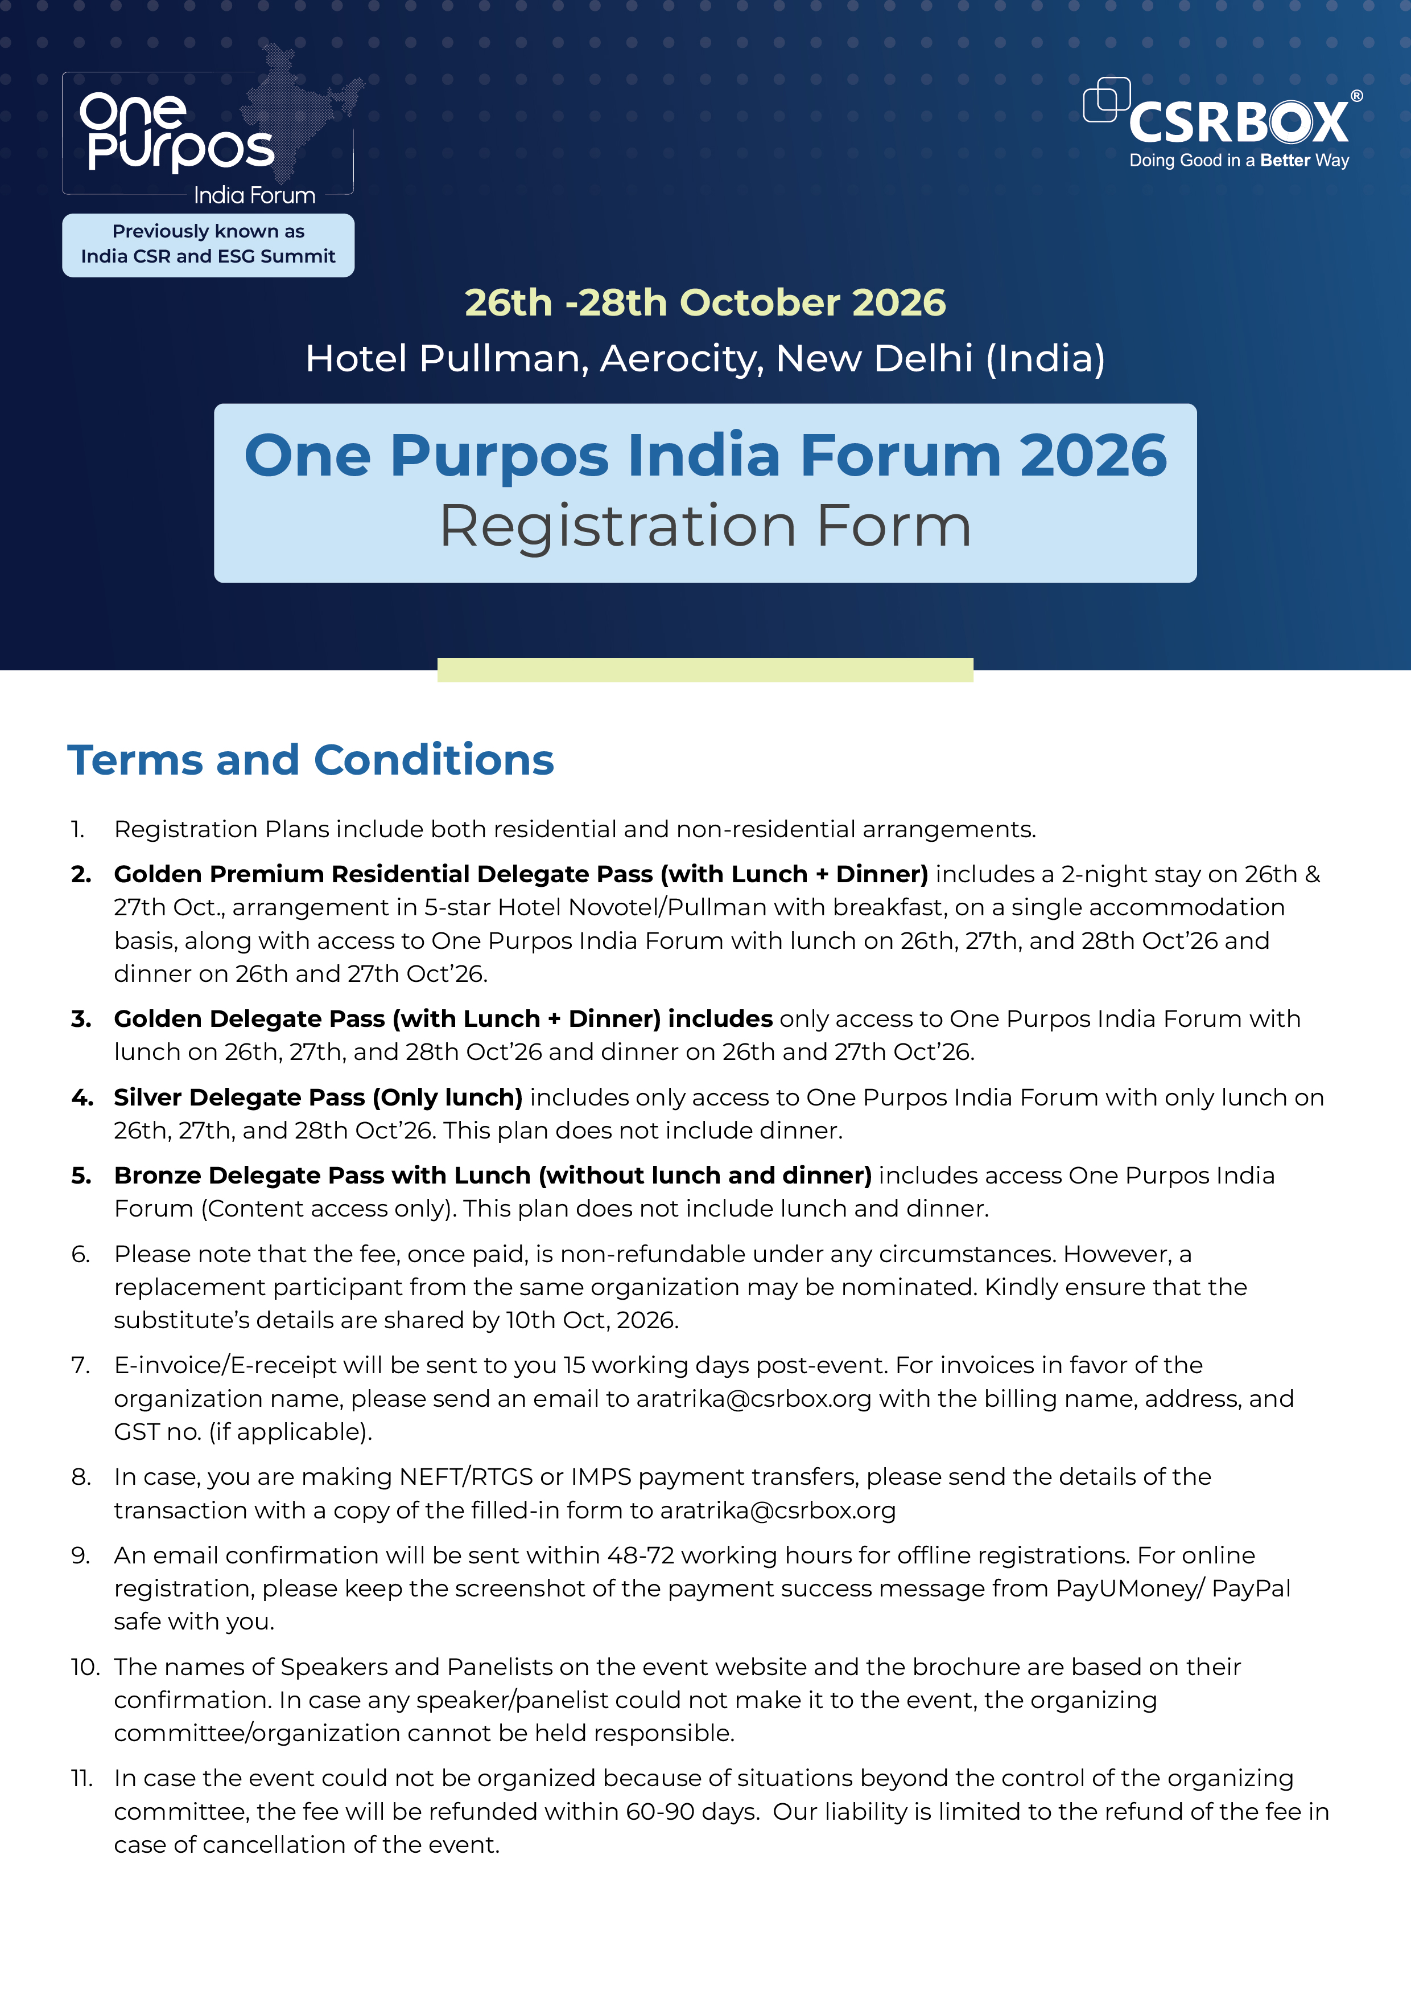

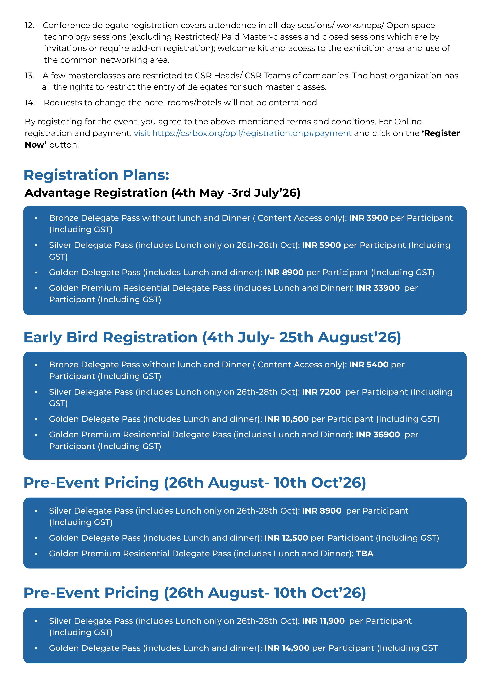

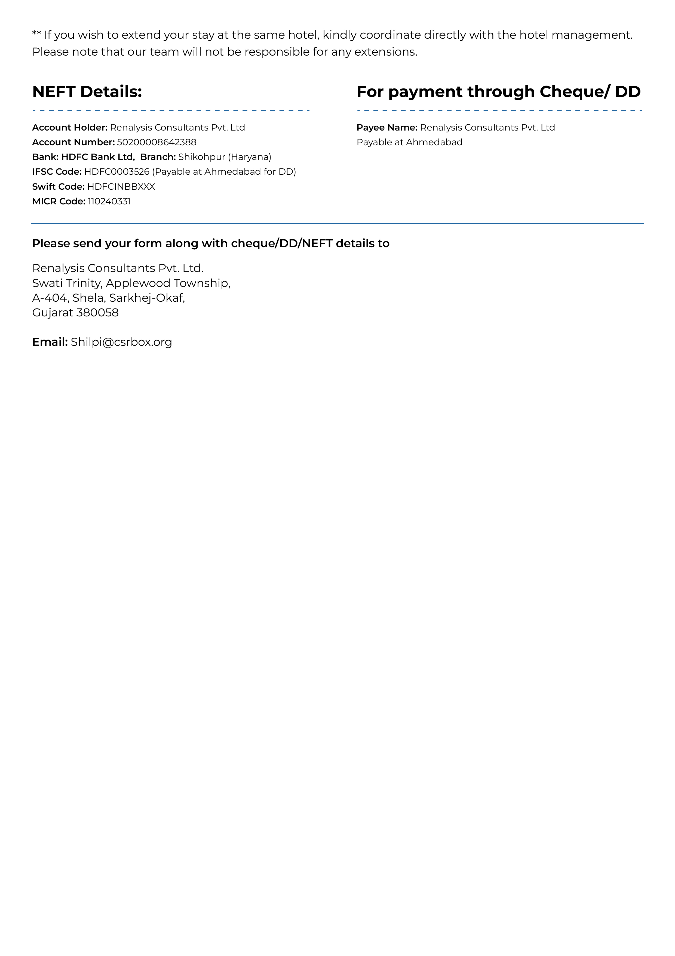

Registration Form
Your Name
Email
Mobile Country Code
Organization
Country State
City/District

No. of participants
Total amount (INR/USD)
Name of Participants | Gender | Designation | Email

Payment Details
Cheque/DD no Amount
Bank
NEFT Details:
Date Amount
Transaction ID
Signature
Note: Please send the filled-in form to aratrika@csrbox.org along with payment details. In case of cheque/DD send a hard copy of the form to our Ahmedabad office. Please mention your name and mobile number on the back of the DD/Cheque.
Renalysis Consultants Pvt. Ltd. (NGOBOX)
Swati Trinity, Applewood Township,
A-404, Shela, Sarkhej-Okaf,
Gujarat 380058
Telephone: +91 9560352170 / 9971429654
Email: Shilpi@csrbox.org

