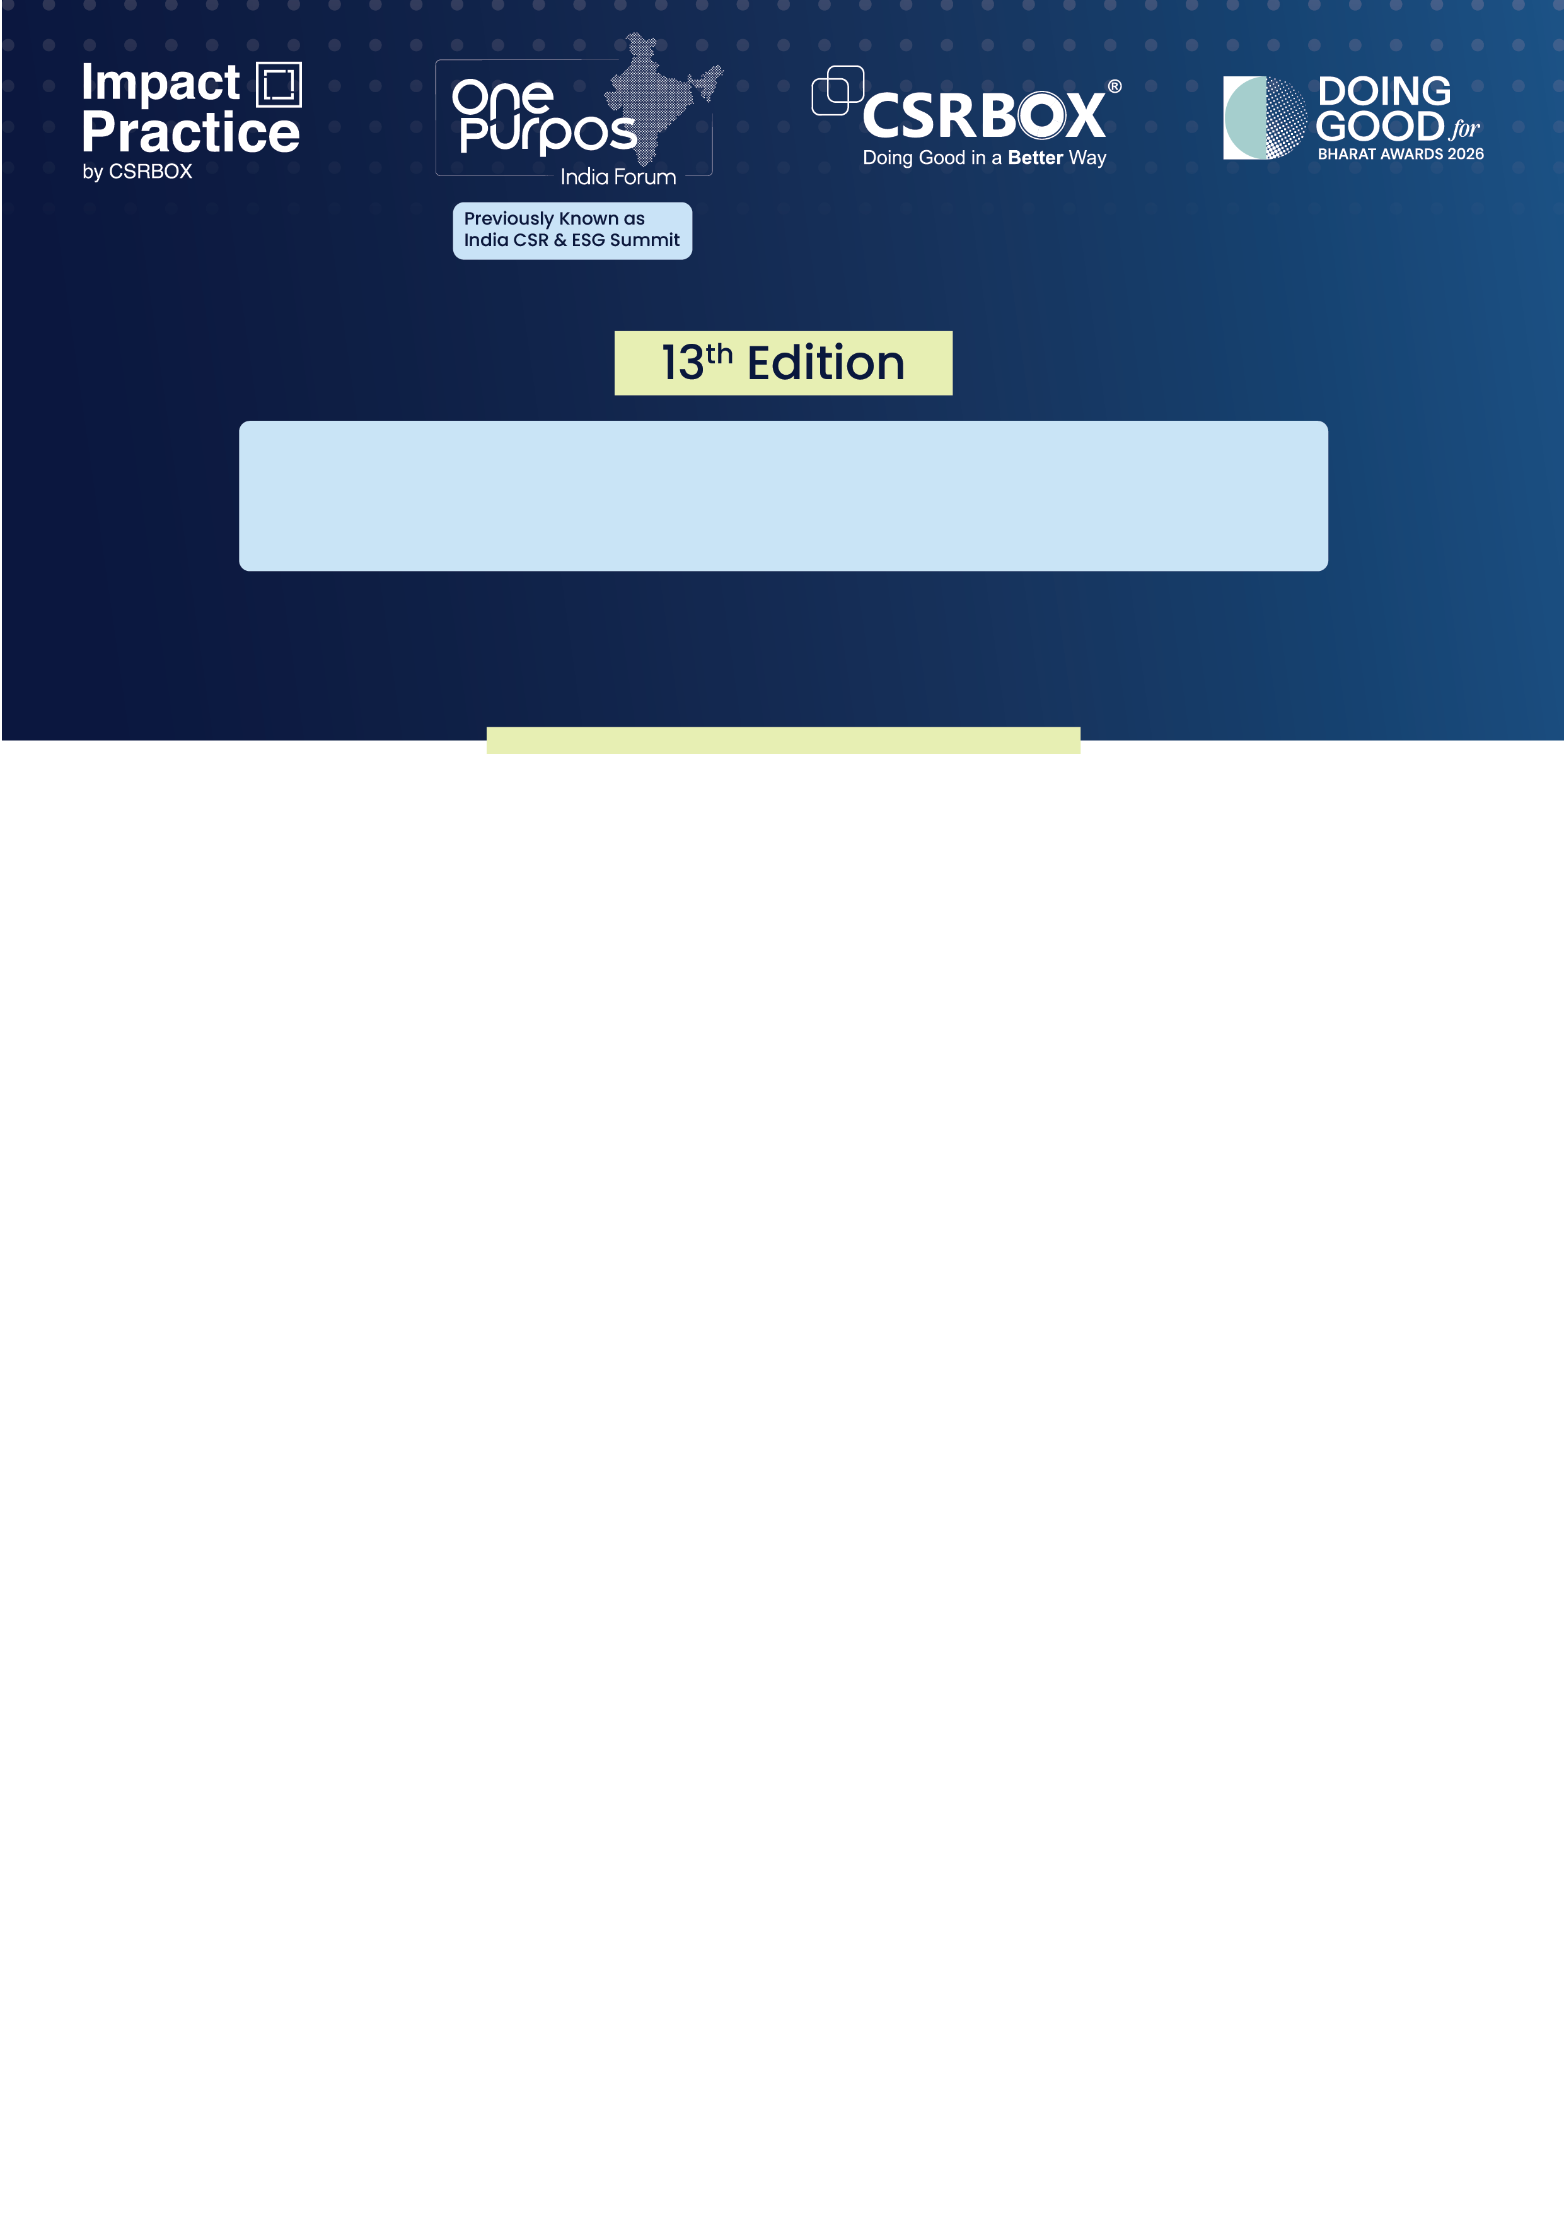

One Purpos India Forum 2026

Doing Good for Bharat Awards 2026- Application Form (Category B)

Category B. Doing Good Through Business; Social Responsibility (Applying as a Business/ Corporate)

Category Brief - Recognising impactful CSR initiatives at the community level by a Business/ Corporate. Please note that this category aims to recognise businesses integrating social and environmental responsibility into their core operations and corporate citizenship efforts in Education, Healthcare, Women and Inclusion, Rural Development and Employee Volunteering Programs.

Who can Apply: Businesses and corporations eligible for CSR spending as per the Section 135 of the Companies Act 2013.

Please mark all applicable eligibility criteria using the ✅ symbol to proceed. (Kindly note that all the points are mandatory)

- The applicant must be a company registered with the Ministry of Corporate Affairs (MCA), Government of India, or operating under the guidelines of the Reserve Bank of India (RBI).
- The company must have recorded a minimum annual revenue of INR 500 crore in Financial Year 2025–26, as per the recognised Indian Accounting Standards.
- The nominated project, programme, or group of initiatives must have a minimum funding outlay of INR 40 lakh in either:
- FY 2024–25, or
- FY 2025–26, specifically through CSR expenditure.
- The nominated project, programme, initiative, or group of activities must not have been recognised as a Winner or Runner up at the Doing Good for Bharat Awards in FY 2024–25 or FY 2025–26. Such projects are not eligible to apply in the current award cycle

It is mandatory to submit supporting documents for verification of eligibility. These include:
- Certificate of incorporation or equivalent registration proof
- Audited financial statements for FY 2025–26
- Project financial summary or utilisation report
- Any additional documents to support during the evaluation process

Please select only one sub-category. If you wish to apply for more than one sub-category, please submit a separate form for each additional application. Please note that applicants can apply in up to two sub-categories. If more than two sub-categories are selected, only the first two will be considered.

Sub-category (Please tick in front of the appropriate sub-category)
B1. Doing Good for Education
B2. Doing Good for Healthcare
B3. Doing Good for Women and Inclusion
B4. Doing Good for Rural Development
B5. Workforce for Good (EVP)

***Please use the specific application template for the Category A to F, given on the web
(Please read the award guidelines and brochure carefully before submitting this form)

Submission of Application
- Applicants are required to upload the application form along with the supporting documents on the platform: https://csrbox.org/opif/dgb_award.php
- To upload, please first register yourself on the platform
- If already registered, then login to upload and submit the application form
- We are accepting online applications only; hence, all the supporting documents (optional) need to be uploaded on the provided platform link only

Section A: Organisational Profile

Name of the Organisation
Date and Year of Establishment | DD/MM/YYYY
Legal Status (Specify registration under the Companies Act or other legal provision)
Name of the Primary Contact Person for Application
Designation
Email id
Contact Number
Name of the Secondary Contact Person for Application
Designation
Email id
Contact Number
Section B: About the Project/Initiative
Project/Initiative Name
Start Date | DD/MM/YY
End Date | DD/MM/YY
Total Project/Initiative Budget for FY 2024-2025 (if applicable) (in INR Cr.)
Total Project/Initiative Budget for FY 2025-2026 (if applicable) (in INR Cr.)
Brief description (objective and scope) of the project/initiative (max 250 words)
Project/initiative geography (Specify State, district, blocks etc)
Total no. of beneficiaries the project (Direct and Indirect both if applicable)
Name of the company/companies or other organisations who has/have given funding for the project/initiative along with the break up (in INR)

Note: The assessment of Awards applications/nominations is based on projects/programs/initiatives executed during the financial year 2024-2025 and 2025-2026. Eligible projects or programs must have been implemented in one or both of these years.

Section C: Please write the synopsis (summarise version) of the initiative/application with a reasoning for the category-fit for the application (Minimum 300 words and maximum 500 words).

Section D Relevance: (Each question to be answered in max. 250 words)

- How did the company identify the need for the project/ initiative? Please upload supporting documents and data pointers (such as Need Assessment or Baseline) if available.
- How does your project address the current national, state, or local challenges of community needs and align with national priorities, SDGs or regional conservation goals? Please provide specific examples of identified challenges and how the project addresses them.
- Please state any culturally sensitive practices or social inclusion aspects that have been integrated into the project.
- Please elaborate on the ‘Theory of Change’ for the project, focusing on the indicators below. (Please ensure that the description should include both quantitative and qualitative aspects).

ToC Framework Indicators | Description
Activities
Output
Outcome
Impact

Section E: Project Design Innovation and Approach (Each question to be answered in max. 250 words)

- What new, improved or innovative technologies (if applicable) were/are being implemented in this project?
- What measures were/are in place to assess their effectiveness in social development or any other related issues?
- Justify how the project has the potential to be replicated and scaled in the future. Provide supporting evidence.
- How was the top management of the company involved in the planning and execution of the initiative/project?
- Were/Are local stakeholders and local community members involved in the planning and implementation processes of the project/initiative? If yes, describe how they were/are involved.
- Were there any significant roadblocks/challenges in the project implementation? If yes, what were those and how did you overcome those?

Section F: Impact (Each question to be answered in max. 250 words)

- Provide a total of 5 key pointers (both Quantitative and Qualitative each) highlighting the magnitude of change brought about by the initiative.

Section G: Sustainability (Each question to be answered in max. 250 words)

- Please elaborate on the collaborations forged with NGOs, Government agencies, local stakeholders or other organisations to support the project. Specify the role of each partner in ensuring the sustainability of the initiative/project.
- What further strategies are in place to ensure the sustainability of the initiative?

Section H: Awards and Recognitions (Each question to be answered in max. 250 words)

- Provide details of any awards or recognition you have received for this project/initiative.
- Why do you think your organisation should be considered for this award? Please provide justification.

Section I: Documents to be submitted (if any):

- Please upload the below mentioned documents (if applicable):
- Images, videos or any other media related to the project/initiative
- Project completion report
- Third-party evaluation and/or endline project reports
- Annual reports
- Case Studies and testimonials
- Kindly provide the appropriate web-links in the table below for any additional information.

S. No. | Web-link | Brief note about the link

